**mRNA Codon Optimization Protocol**

The following protocol has been designed and tested to yield approximately 5mgs of mRNA. Final yields may vary due to template quality and size of the mRNA being produced. This example is for the codon optimization of _____.

The following protocol has been designed and tested to generate a list of satisfactory codon optimized constructs. Downstream success depends construct to construct.

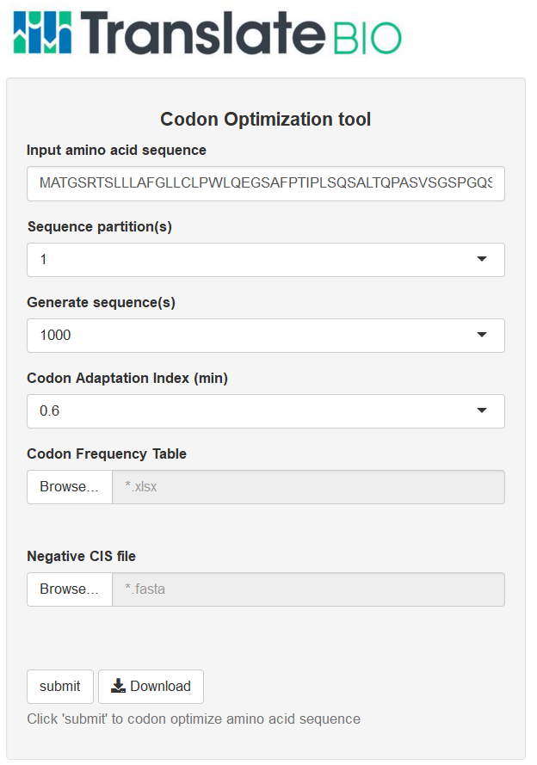

**Figure 1**: Translate Bio Codon Optimization application

Parameters:

**Input Amino acid sequence**

Input protein sequence to be codon optimized. Amino acid sequences ought to be free of new line characters, tabs, and white space(s).

*Example:*

**MGVHECPAWLWLLLSLLSLPLGLPVLGAPPRLICDSRVLERYLLEAKEAENITTGCAEHCSLNENITVPDTKVNFYAWKRMEVGQQAVEVWQGLALLSEAVLRGQALLVNSSQPWEPLQLHVDKAVSGLRSLTTLLRALGAQKEAISPPDAASAAPLRTITADTFRKLFRVYSNFLRGKLKLYTGEACRTGDR\***

**Sequence partitions:**

Input the number of partitions to an inputted amino acid string.

*Example:*

**No Partitions**

**3 Partitions**

**2 Partitions**

Partition value of **1,** will not divide the amino acid string. It is ideal to partition the sequence so that no partition window will be greater than 100 amino acids in length.

**Generate sequence(s):**

TBio’s codon optimization relies on a series of sequences generations and filters. Indicate the number of sequences to generate for EACH partition window. If there are three partition windows & the user chooses to generate 5000 sequences. A total of 15000 sequences will be generated (5000 sequences for partition 1, 5000 sequences for partition 2, & 5000 sequences for partition 3). The number of total generated sequences will influence the total runtime of the algorithm depending on the hardware of the computational tool used.

**Analyzing and setting codon usage bias**

**Codon Adaptation Index (min):**

Codon Adaptation Index measures the deviation of codons in a transcript from a reference set frequencies. Indicate the minimum codon adaptation cutoff for the algorithm to return.

**Codon Frequency Table**:



Figure 2: TBio Codon Frequency table

TBio’s codon optimization algorithm uses a customized codon frequency table to codon optimize constructs. Users can input different frequencies pertaining to different experiment conditions (Cell lines, tissues types, etc). Column 4, contains the frequency values that are used to generate a specific corresponding codon (column 3) given an amino acid (column 2). The Status column (column 5) is used to identify inhibitory clusters of rare codons (Codon frequency distribution). The Relative Adaptiveness column (column 7) is used to calculate codon usage bias (Codon adaptation Index).

**Negative CIS file**

The Negative CIS file is a fasta file containing known regulatory elements that will be looked for in the generated sequences.

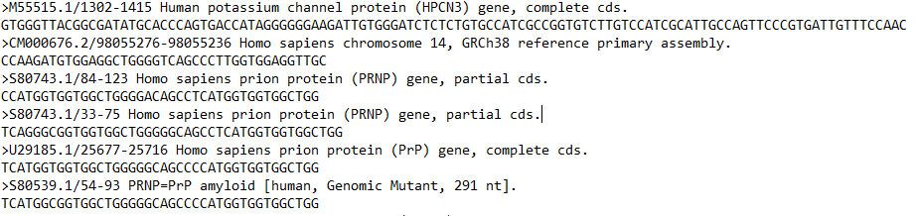

Figure 3:

**Worflow**

**Step1**: Input all parameters

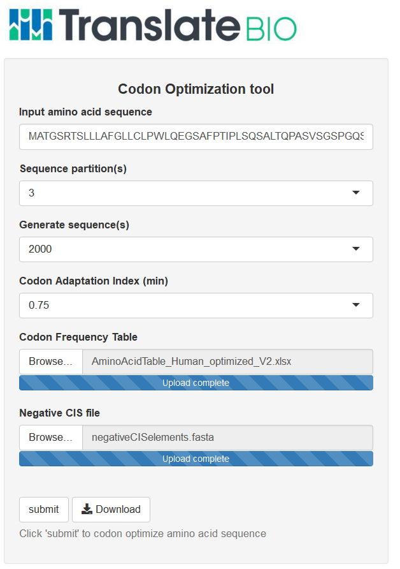

Figure 3**:** Successful parameter input of TBio’s codon optimization tool

**Step2**: Click the Submit button to initiate the codon optimization tool.

**Step3**: Track the progress of the Codon optimization job

TBio’s codon optimization tools indicates loading notifications to allow the users to track the progress of the algorithm.

**Step4**: Download generated codon optimized transcripts.

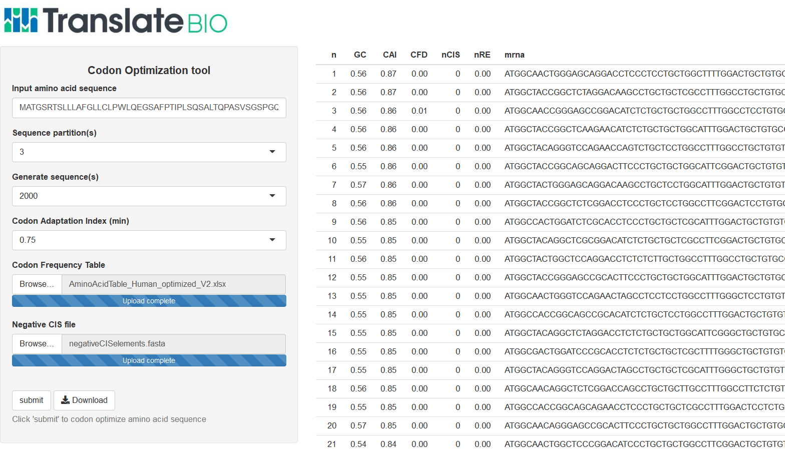

**IVT**

RNAse Free Water 753.6L

1mg/mL Linearized Plasmid 100 L

10x SP6 IVT Buffer 150 L

100mM ATP 75 L

100mM GTP 75 L

100mm CTP 75 L

100mM UTP 75 L

100mM DTT 150 L

0.04kU/L RNase Inhibitor 11 L

1.06 mg/mL Pyrophosphatase 10.6 L

2.01mg/mL SP6 Polymerase 24.9 L

Total Reaction Volume 1500 L

Incubate at 37°C for 90mins in a shaking water bath. After 90mins to remove the template DNA add the following;

10x DNase I Buffer 169.3 L

9.6U/L DNase I (liquid) 23.4 L

Incubate at 37°C for 15mins in a shaking water bath.

**Purification**

* Add 3.9mL of GSCN precipitation buffer and mix thoroughly.
* Add 2.9mL of ethanol (100%) to the diluted RNA. Mix thoroughly by shaking.
* Apply the sample to a RNeasy maxi column placed in 50mL centrifuge tube (supplied). Maximum loading volume 15mL. Close tube gently, and centrifuge for 5 min at 3000–5000 x g. Discard the flow-through. Repeat until total reaction volume has been run over the column. Discard the flow-through after each centrifugation step.
* Add 10mL 80% EtOH to the RNeasy column. Centrifuge for 2mins at 3000–5000 x g to wash the column. Discard the flow-through.
* Add another10mL 80% EtOH to the RNeasy column. Centrifuge 10mins at 3000–5000 x g to dry the membrane.
* Transfer the RNeasy column to a new 50mL collection tube (supplied). Pipet 2mL of 37C RNase-free water directly onto the membrane. Let it stand for 2mins and then centrifuge for 2mins at 3000–5000 x g.
* Repeat the elution step 4 additional times using the first eluate by transferring the eluate from the bottom of the 50mL conical to the Qiagen spin column membrane.
* Determine concentration by UV abs at 260nm using a Nano drop 2000 and dilute to conc required for Cap-Tail reaction (usually 2mg/mL) using ultra-pure H2O.

**Capping**

Assemble the following components in order

Water 16 L

2mg/mL RNA 2500 L

10x Capping Buffer, pH 7.5 325 L

325mM GTP 10 L

0.05mg/L SAM-Tos 21.5 L

0.04kU/L RNase Inhibitor 20 L

1mg/mL 2'-O-Methyl Transferase 152 L

1mg/mL Guanylyl Transferase 205 L

Total Cap reaction volume 3250 L

Incubate at 37°C for 90mins in a shaking water bath. Proceed directly to tailing.

**Tailing**

For a 200nt polyA tail

Water 97 L

10x Tailing Buffer, pH 7.5 400 L

100mM ATP 16 L

1.48mg/mL Poly-A Polymerase 237 L

Total Tailing reaction volume 4000 L

Incubate at 37°C for 30mins.

Stop reaction by adding 100L EDTA (0.5M) and incubate at 37°C for 5mins.

Purification

* Using the Qiagen RNeasy Maxi kit:
* Add 9.4mL of GSCN precipitation buffer to each tube, and mix thoroughly.
* Add 7.0mL of ethanol (100%) to each tube. Mix thoroughly by shaking.
* Apply the samples to a RNeasy maxi column placed in 50 ml centrifuge tube (supplied). Maximum loading volume 15mL. Close tube gently, and centrifuge for 5 min at 3000–5000 x g. Discard the flow-through. Repeat until total reaction volume has been run over the column. Discard the flow-through after each centrifugation step.
* Add 10mL 80% EtOH to the RNeasy column. Centrifuge for 2mins at 3000–5000 x g to wash the column. Discard the flow-through.
* Add another10mL 80% EtOH to the RNeasy column. Centrifuge 10mins at 3000–5000 x g to dry the membrane.
* Transfer the RNeasy column to a new 50mL collection tube (supplied). Pipet **2mL** of 370C RNase-free water directly onto the membrane. Let it stand for 1min and then centrifuge for 3mins at 3000–5000 x g.
* Repeat the elution step 4 additional times using the first eluate by transferring the eluate from the bottom of the 50mL conical tube to the Qiagen filter.

Measure mRNA concentration by spectrophotometry and observe 260/280 and 260/230 concentrations. Expected 260/230 values are commonly in the range of 2.0-2.2. If the ratio is appreciably lower than expected, it may indicate the presence of contaminants which absorb at 230 nm. Dilute RNA to final desired conc. (usually 1 mg/mL) using ultra pure H2O.